Shattuck Public Library, 101 South Main
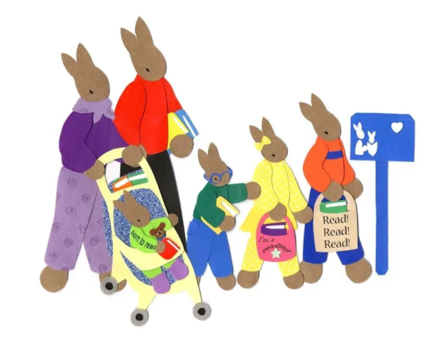

Saturday February 5th - 10:00 AM to 12:00 PM
Come just as you are, or dressed like your favorite book character for refreshments and fun filled activities at the Shattuck Public Library!
Activities include:
- Special Guest Readers - Doris Akers, Kimberly Clingenpeel, and children’s author Missy Brickman.
- Author Meet and Greet – Missy Brickman will have signed copies of her book “Mommy’s Hot Pink Heels” available for purchase.
- Face Painting by: Dixie Smith
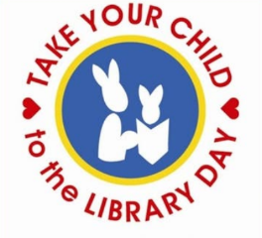
- Prize Drawings
- Fun Craft – DIY bookmarks
- Sign-up for a library card

*Children under 10 must be accompanied by a parent/caregiver.

